**PROJECT REPORT**

**ELECTRIC VEHICLE ANALYSIS**

**Name** – Abhishek Babanrao Satpute

**Project Title** – ELECTRIC VEHICLE ANALYSIS

**Date** – 13 jan 2025

**Technology** – Power Bi

**Tools-** Power BI Visualization Tools

**Project Description :**

This report offers a comprehensive analysis of the United States electric vehicle (EV) market, examining vehicle distribution, model types, and adoption trends. Key performance indicators (KPIs) such as total EV count, vehicle type segmentation (Battery Electric Vehicles (BEVs) and Plug-in Hybrid Electric Vehicles (PHEVs)), and geographic and manufacturer data are presented via a dynamic dashboard. The rapidly expanding EV market is fueled by technological innovation, government support, and rising consumer demand for sustainable transportation. This Power BI project analyzes and visualizes various aspects of the EV market, including sales trends, market share by region and manufacturer, consumer preferences, governmental policies, and charging infrastructure. Through interactive Power BI visualizations, the report identifies key drivers of EV adoption, pinpoints challenges, and provides actionable insights for manufacturers, policymakers, and other stakeholders to navigate this evolving market.

**Objectives:**

**The primary objectives of this project are:**

1. To analyze the growth and adoption trends of electric vehicles (EVs) across different regions and markets.
2. To compare EV market share by manufacturer and identify the leaders in the industry.
3. To assess the availability of EV charging infrastructure globally and by region.
4. To examine the impact of government policies and incentives on the growth of the EV market.`0
5. To analyze consumer preferences and demographics associated with electric vehicle purchases.
6. To identify challenges and opportunities within the EV market, including pricing, range anxiety, and infrastructure issues.

**Data Summary:**

* Total vehicles
* Average Electric Range
* BEV Vehicles
* PHEV vehicles

**1. Total Vehicles and Average Electric Range:**

* Total Vehicles:
  + The dataset reveals there are 150,420 electric vehicles. This figure represents the overall size of the electric vehicle (EV) market within the analyzed scope.
  + This shows a substantial adoption rate of EVs, which is likely due to increasing environmental awareness, government policies, incentives, and advancements in EV technology.
* Average Electric Range:
  + The average electric range of these vehicles is 67.83 miles.
  + This range reflects the average distance an EV can travel on a single charge. While this is sufficient for daily commuting and urban trips, it might be less appealing for long-distance travelers.
  + The relatively moderate average range also highlights the need for continued development in battery technology to make EVs more practical and competitive with traditional fuel-based vehicles.

**2. Battery Electric Vehicles (BEVs):**

* Count and Market Share:
  + There are 117,000 BEVs in the dataset, making up 78% of the total EV population.
  + BEVs rely entirely on electricity and have no gasoline engine, making them fully zero-emission vehicles.
* Significance:
  + The dominance of BEVs suggests that most EV buyers prefer vehicles with no reliance on fossil fuels. This trend aligns with global goals to reduce greenhouse gas emissions.
  + BEVs often have fewer moving parts, which reduces maintenance costs, and they benefit from technological improvements in range and charging infrastructure.

**3. Plug-in Hybrid Electric Vehicles (PHEVs):**

* Count and Market Share:
  + PHEVs account for 34,000 vehicles, or 22% of the total EV market.
  + These vehicles combine an electric motor with a gasoline engine, allowing them to run on either electricity or gasoline.
* Role and Benefits:
  + PHEVs act as a transitional option for consumers who might be hesitant to switch fully to electric vehicles due to concerns like charging infrastructure availability or range anxiety.
  + They provide the flexibility to use electricity for short trips while relying on gasoline for longer distances.
  + Despite their smaller market share compared to BEVs, PHEVs still contribute significantly to reducing overall emissions and fuel consumption.

Summary:

* The total EV population of 150.42K highlights growing adoption and the increasing presence of electric vehicles in the market.
* BEVs dominate the market with a 78% share, reflecting a shift towards completely electric-powered transportation, which is better for the environment.
* PHEVs occupy a 22% share, offering a flexible and less risky option for consumers transitioning to electric vehicles.
* The average range of 67.83 miles suggests that while EV technology is improving, further advancements are needed in battery efficiency to make EVs more appealing for longer trips.

These insights underline the progress and challenges of the electric vehicle sector, emphasizing the importance of supporting infrastructure, technology upgrades, and consumer incentives to accelerate adoption.

**Analysis and Findings**

1] Yearly Sales Trends:

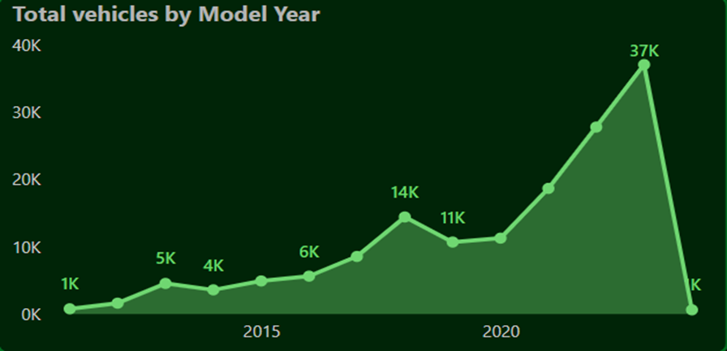

• Steady Growth Over Time:

* The chart indicates a steady increase in the total number of electric vehicles (EVs) over the years.

• Significant Milestone Years:

* 2015: Marked a modest growth with around 6K total vehicles.
* 2020: A significant spike, reaching 37K vehicles, showcasing a growing adoption of EVs.

• Market Expansion Post-2020:

* The rapid rise in EV adoption from 2020 reflects advancements in EV technology, government incentives, and increasing consumer interest.

• Implications for Stakeholders:

* The data highlights key growth periods that can guide manufacturing, investment, and policy decisions.

**Key Points:**

**2.Total Vehicles by State**

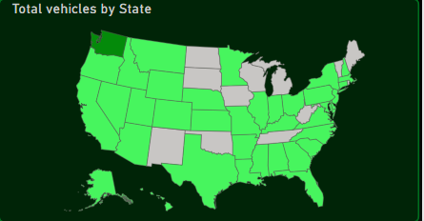

1. **Geographical Distribution of EVs:**
   * The map provides a clear visualization of electric vehicle adoption across various states in the United States.
   * States shaded in darker green represent higher EV adoption rates, while lighter shades indicate relatively lower adoption.
2. **Regional Leaders:**
   * Certain states, like Washington and California, show significantly higher numbers of electric vehicles compared to other regions.
   * These states often lead in EV policies, infrastructure, and incentives, promoting greater adoption.
3. **Market Gaps:**
   * States shaded in gray or light green have fewer electric vehicles, indicating opportunities for growth and adoption.
   * These areas may benefit from increased public awareness, improved charging infrastructure, and targeted policy incentives.
   * 9
4. **Actionable Insights:**
   * Businesses, policymakers, and utilities can use this data to focus efforts on underserved regions to boost adoption.
   * Infrastructure investments in charging networks in low-adoption states can accelerate EV penetration.

3] **Total Vehicles by Make**

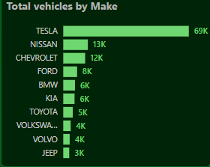

1. **Dominance of Tesla:**
   * Tesla leads the market with a significant margin, accounting for 69K vehicles, showcasing its dominance in the EV sector.
2. **Other Major Players:**
   * Nissan (13K) and Chevrolet (12K) follow Tesla, indicating a competitive but distant second and third place in EV adoption.
3. **Mid-Tier Brands:**
   * Ford, BMW, and Kia each contribute around 6K-8K vehicles, reflecting their growing presence in the market.
4. **Emerging Competitors:**
   * Toyota, Volkswagen, Volvo, and Jeep have smaller but notable contributions, with numbers ranging from 3K to 5K vehicles, indicating potential for future growth.
5. **Market Insights:**
   * Tesla's dominance highlights its brand appeal and leadership in EV technology, while other manufacturers show varying levels of penetration, leaving room for market expansion.

**4] Total Vehicles by (CAFV) Eligibility**

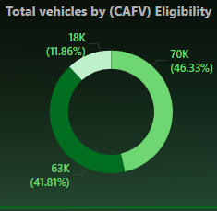

1. **Most Cars Are Eligible:**
   * Nearly half (46%) of the cars, which is 70,000, meet all the rules to qualify for special benefits (CAFV). This shows that many cars are following the guidelines.
2. **Some Are Partially Eligible:**
   * About 42% (63,000 cars) qualify for some benefits but not all. These cars still follow many rules but aren’t perfect yet.
3. **A Few Are Not Eligible:**
   * Only 12% (18,000 cars) don’t qualify at all. This is a small number compared to the rest.
4. **What This Means:**
   * Most cars on the road are meeting or trying to meet the standards, which is a good sign for the environment and future car designs.

**5] Total Vehicles by Model – Explanation**

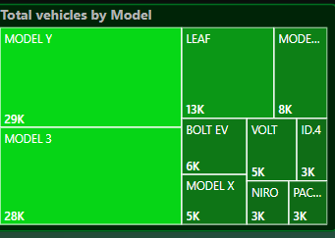

1. **Dominance of Tesla Models:**
   * The Tesla **Model Y** leads as the most popular electric vehicle model with **29,000 vehicles**.
   * Close behind is Tesla's **Model 3**, with **28,000 vehicles**, showcasing Tesla's strong influence in the electric vehicle market.
2. **Significant Contributions by Other Models:**
   * The **Nissan Leaf** has a notable presence with **13,000 vehicles**, reflecting its position as a popular, affordable electric car choice.
   * Tesla's **Model S** is also prominent, with **8,000 vehicles**, known for its premium performance and luxury.
3. **Mid-Range Popularity Models:**
   * Chevrolet's **Bolt EV** accounts for **6,000 vehicles**, demonstrating its popularity as a practical and affordable EV.
   * The **Volt** and Tesla's **Model X** each have **5,000 vehicles**, highlighting their role in providing variety for different customer needs.
4. **Lower-Range Models:**
   * Other models, such as the **ID.4**, **Niro**, and **Pacifica**, contribute with around **3,000 vehicles** each, reflecting a growing diversity of electric vehicle options.

**Analysis:**

* **Tesla's Dominance:** Tesla's Model Y and Model 3 make up a large proportion of the total vehicles, highlighting the company's leadership in innovation, range, and customer preference.
* **Other Contributions:** Manufacturers like Nissan, Chevrolet, and Volkswagen are also playing crucial roles in increasing EV adoption, focusing on affordability and functionality.
* **Market Trends:** This tree map emphasizes Tesla's strong brand appeal while showing the growing competition among other automakers in expanding the electric vehicle ecosystem.

**SnapShpot:-**

**DashBoard**

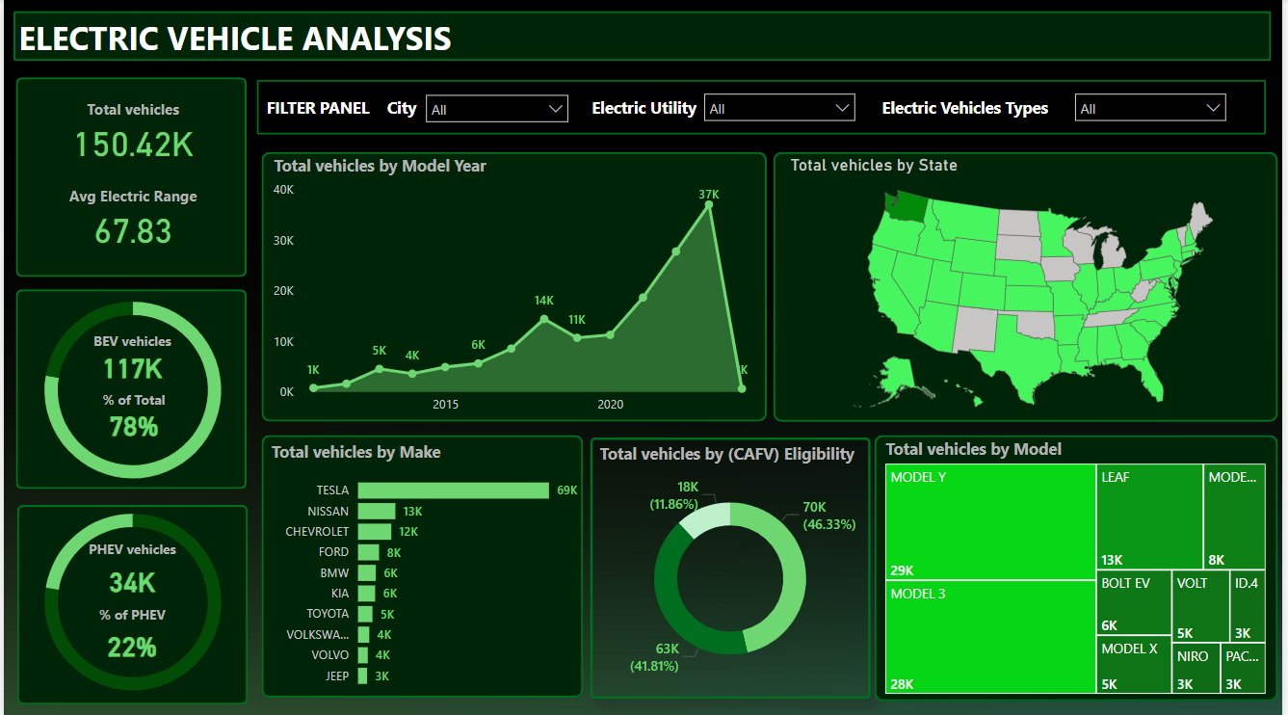

**Recommendations:-**

**Recommendations for Growth of Electric Vehicles (EV) Based on Analysis:**

1. **Enhancing Charging Infrastructure**:
   * **Problem**: Limited access to fast and reliable charging stations is a barrier to EV adoption, especially for long-distance travelers.
   * **Recommendation**:
     + Expand the charging network with more fast-charging stations, particularly along highways and in rural areas.
     + Encourage public-private partnerships to develop comprehensive charging infrastructure.
     + Provide incentives for businesses and homeowners to install charging stations.
2. **Improving Battery Technology**:
   * **Problem**: The average electric range of 67.83 miles is insufficient for some users, leading to "range anxiety."
   * **Recommendation**:
     + Invest in research and development (R&D) for high-density, low-cost batteries to extend vehicle range.
     + Promote partnerships between EV manufacturers and battery technology firms to accelerate advancements.
     + Introduce government subsidies for innovations that improve battery life, charging speed, and safety.
3. **Incentives and Subsidies**:
   * **Problem**: High upfront costs of EVs discourage potential buyers.
   * **Recommendation**:
     + Offer tax rebates, purchase subsidies, or zero-interest loans for EV buyers.
     + Reduce import duties on EVs and EV components to lower manufacturing costs.
     + Provide incentives for manufacturers to produce affordable, entry-level EVs for mass adoption.
4. **Policy Support and Regulations**:
   * **Problem**: Lack of clear policies can slow EV growth.
   * **Recommendation**:
     + Set ambitious national EV adoption targets and create a roadmap to achieve them.
     + Introduce policies mandating a gradual phase-out of internal combustion engine vehicles.
     + Establish standards for EV manufacturing, safety, and recycling to build consumer confidence.

**Conclusion:**

Electric vehicles (EVs) are becoming more popular and are an important step toward reducing pollution and using less fuel. Tesla is leading the market, and fully electric vehicles (BEVs) make up most of the EVs, while plug-in hybrids (PHEVs) also help in the shift to cleaner energy.

The number of EVs is growing because of better technology, longer driving ranges, and government support. States with more EVs show how important good policies and charging stations are. To grow even more, EVs need to become cheaper, have better batteries, and more people need to know about them.

In short, EVs are helping create a cleaner and greener future, and we need to keep working to make them easier and better for everyone to use.

0